

**MUTHAYAMMAL COLLEGE OF ENGINEERING**

(Approved by AICTE, New Delhi and Affiliated to Anna University)

Rasipuram - 637 408, Namakkal Dist., Tamil Nadu.

Air quality ANALYSIS and prediction in Tamil Nadu

From Department Of

**B.TECH(Artificial Intelligence And Data Science)**

**BY :**

Dominic Aakash.A

III-YEAR(AI&DS)

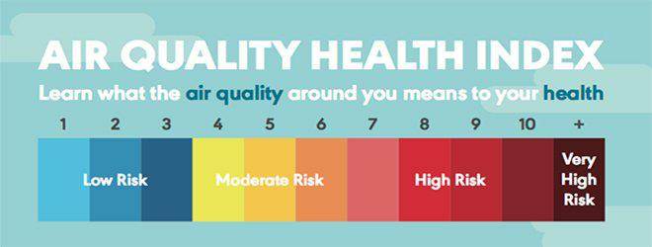**MY UNDERSTANDING :**

My understanding on this project **“AIR QUALITY ANALYSIS AND PREDICTION IN TAMIL NADU”** is that assess current air quality, anticipate future trends, and implement measures to protect public health and the environment through data-driven insights and forecasting.

**AIM OF MY PROJECT :**

The main aim is to efficiently manage and analyze the quality of air in our location.a

**OBJECTIVES OF MY PROJECT:**

* Data collection and analysis.
* Prediction modeling.
* Source identification.
* AQI implementation.
* Policy recommendations.
* Public awareness.

**AUDIENCE UNDERSTANDING:**

It aims to provide actionable insights for improving air quality and safeguarding public health in the region.

**PERFORMANCE ASSESSMENT:**

Evaluate the overall performance by measuring its impact on reducing pollution levels and enhancing public well-being.

**SEARCH ENGINE OPTIMIZATION:**

It ensure that critical air quality analysis and prediction information for Tamil Nadu reaches the widest audience possible.

**COMPETITIVE ANALYSIS:**

Conduct a comprehensive competitive analysis to identify strengths and weaknesses, emerging trends, and potential opportunities.

**GOAL TRACKING:**

Implement effective goal tracking mechanisms to monitor and evaluate the progress and impact.

**CUSTOMER FEEDBACK INTEGRATION:**

Integrate customer feedback systems to gather valuable insights and improve the effectiveness.